**ORTHOGRAPHIC PROJECTION TO**

**ISOMETRIC PROJECTION**

**Problem 1**

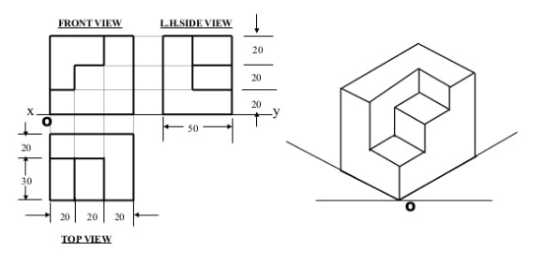

**Problem 2**

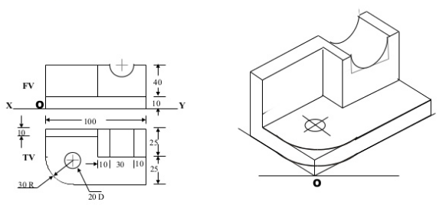

**ISOMETRIC PROJECTION TO**

**ORTHOGRAPHIC PROJECTION**

**Problem 3**

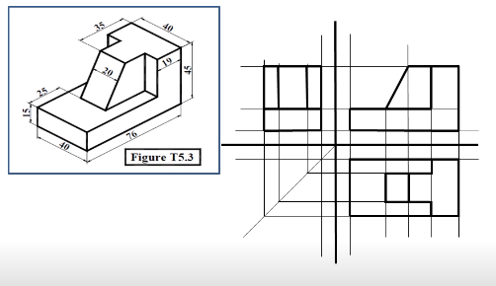

**Problem 4**

